**Retrieving User Resources from Facebook over the OAuth Authorization Code Grant Type**

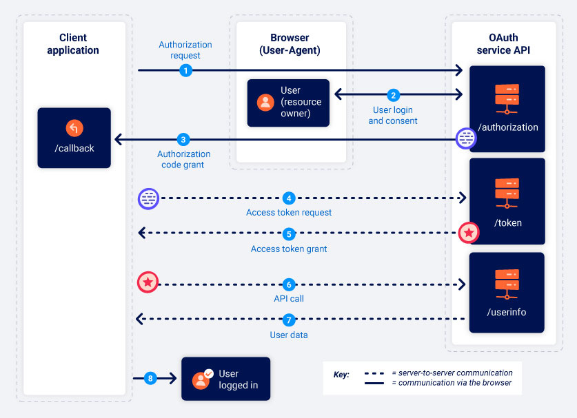

**Step 1 - Registering the Client App in Facebook Developer Website**

First step is to create an application in the developer account on Facebook. Visit https://developers.facebook.com/ and add a new application.

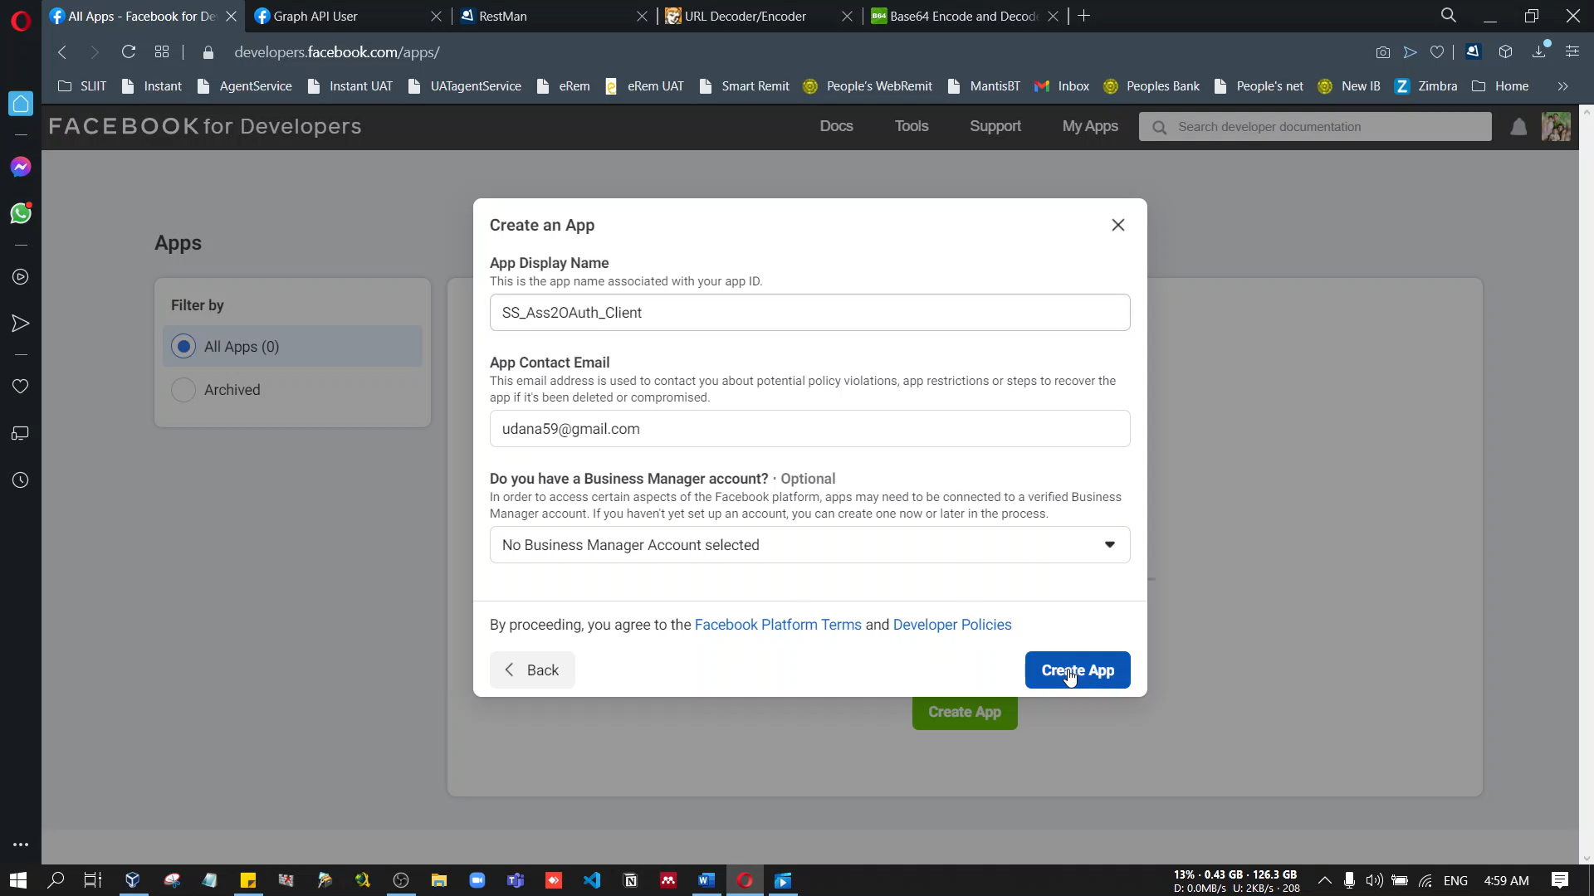

Under the Settings of the “Facebok Login”, need to provide the Redirection Endpoint URL.

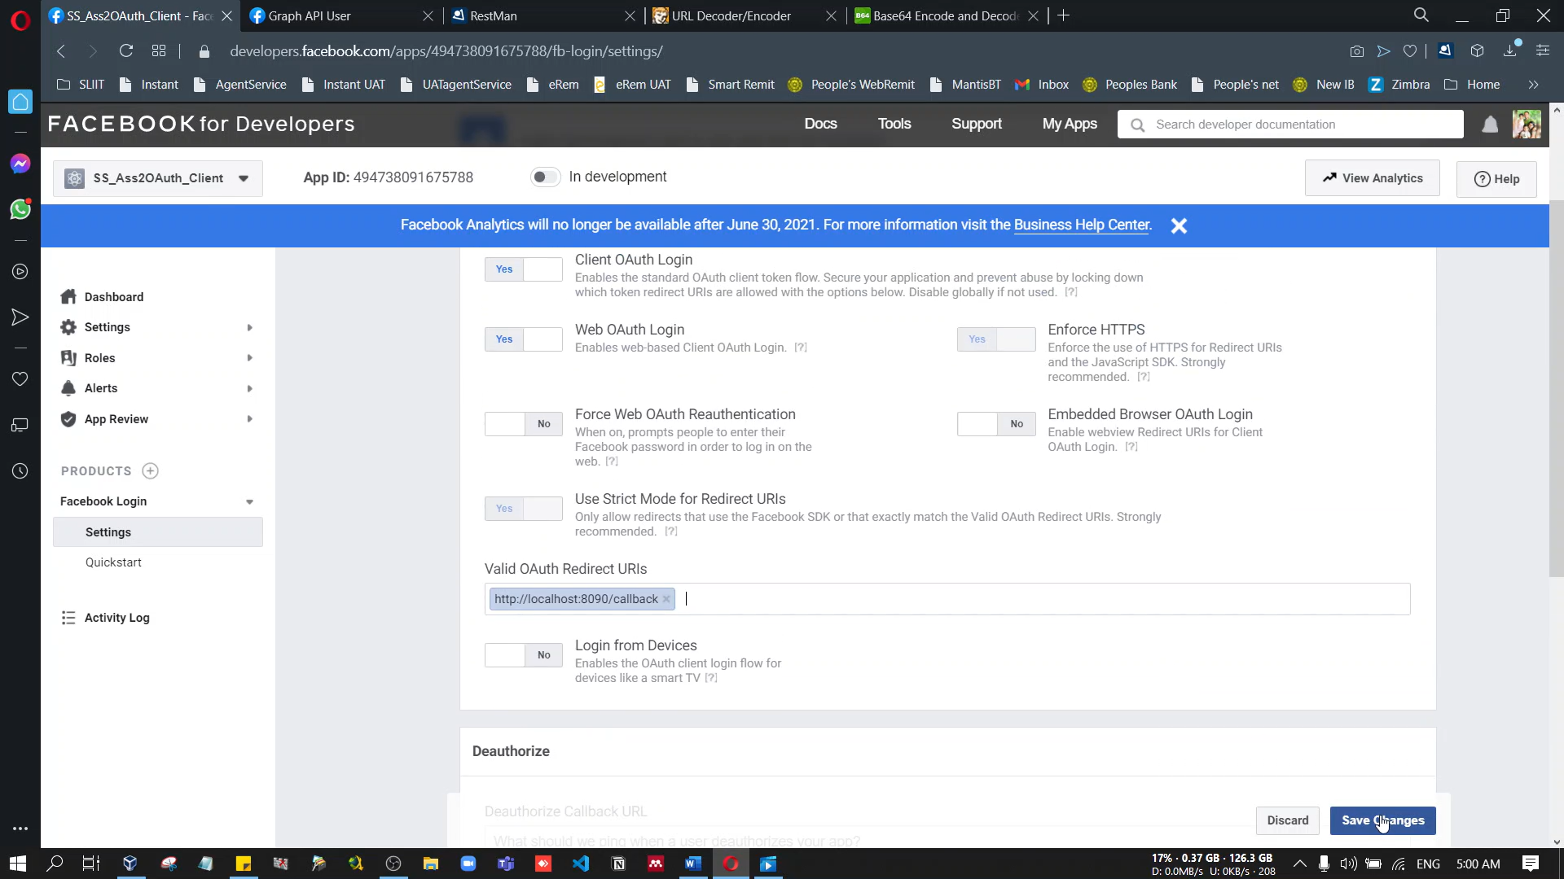

In the Dashboard, you can see the App ID and the App Secret for your app

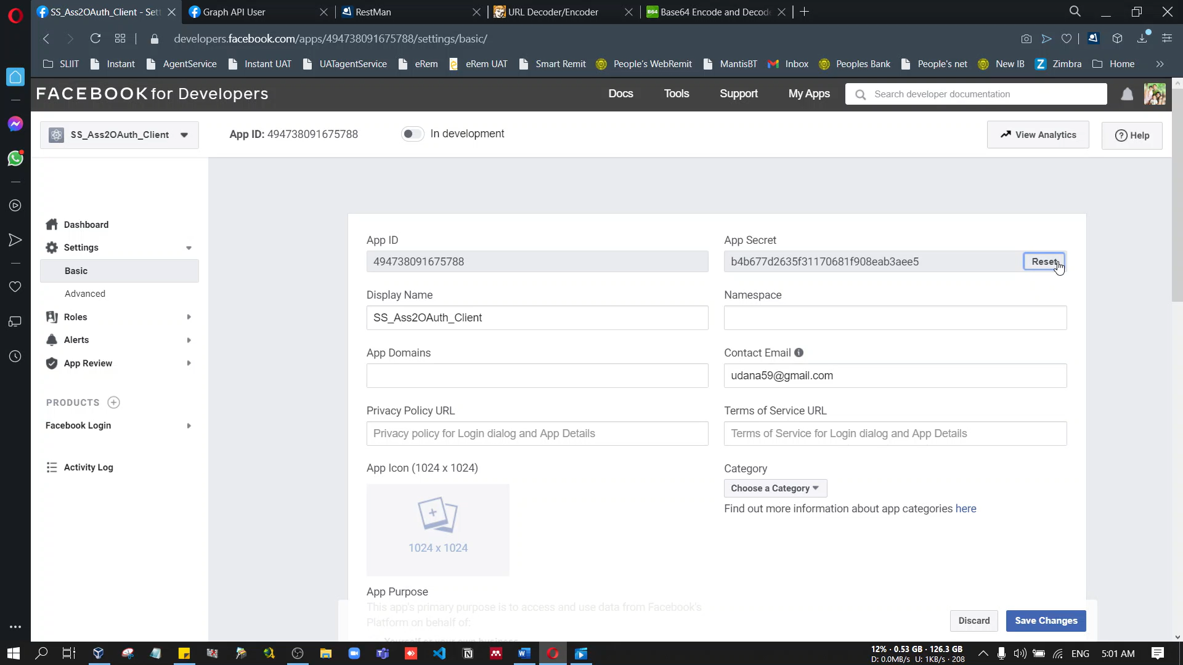

**Step 2 - Obtaining the Authorization Code**

In order to obtain the authorization code from Facebook, send a HTTP GET request to the Authorize Endpoint of Facebook, which is [*https://www.facebook.com/dialog/oauth*](https://www.facebook.com/dialog/oauth).

https://www.facebook.com/dialog/oauth?response_type=code&client_id=494738091675788&redirect_uri=http%3A%2F%2Flocalhost%3A8091%2Fcallback&scope=public_profile%20email&state=123

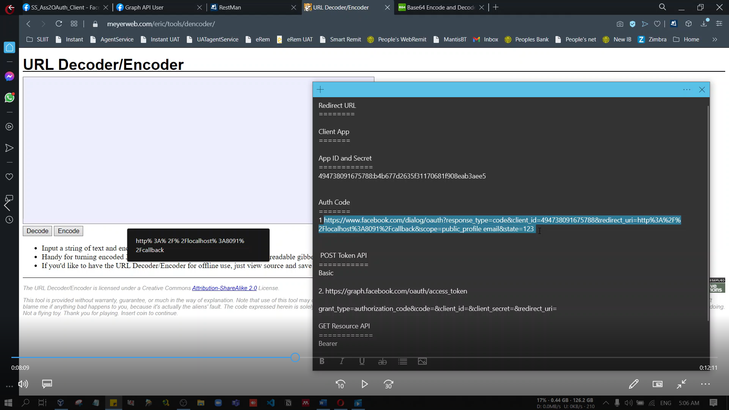

If not logged into Facebook in the browser, first it will ask you to login. Once login, it will show the following popup. This is the “User Consent Page” in OAuth terminology. It will show the resources from the user account that this external **SS_Ass2OAuth_Client app** would be able to access on behalf.

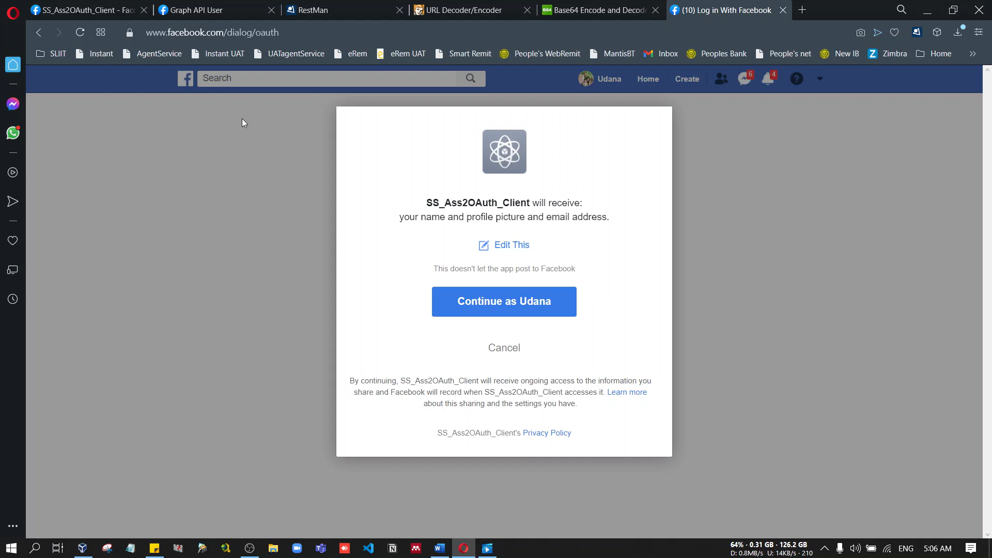

Once Continue, Facebook will redirect the browser to the Redirection Endpoint URL which defined in the app settings and along with the URL, it will send the query parameter code, which is the authorization code.

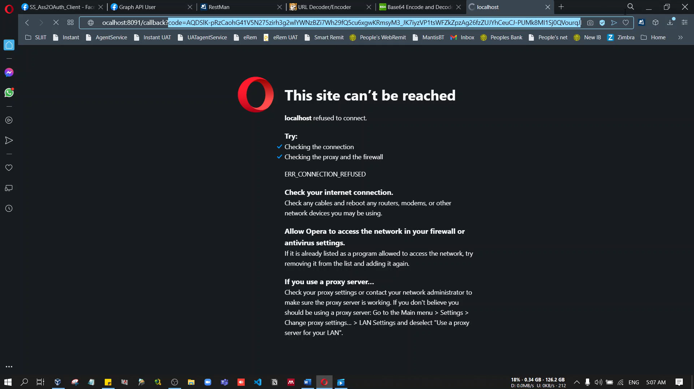

**Step 3 - Obtaining the Access Token**

Request an OAuth access token from Facebook, which can be used to access user resources (permitted with the scopes which requested). For that, the client web application has to send a HTTP POST request to the Token Endpoint of Facebook sending the authorization code received in previous step. The Token Endpoint of Facebook is [*https://graph.facebook.com/oauth/access_token*](https://graph.facebook.com/oauth/access_token).

In addition to that, need to send credentials of the Facebook application (App ID and App Secret) in the HTTP Header. Here, we need to combine the App ID and Secret separating them in a Colon (:) and the value should be encoded in Base64.

494738091675788:b4b677d2635f31170681f908eab3aee5

NDk0NzM4MDkxNjc1Nzg4OmI0YjY3N2QyNjM1ZjMxMTcwNjgxZjkwOGVhYjNhZWU1

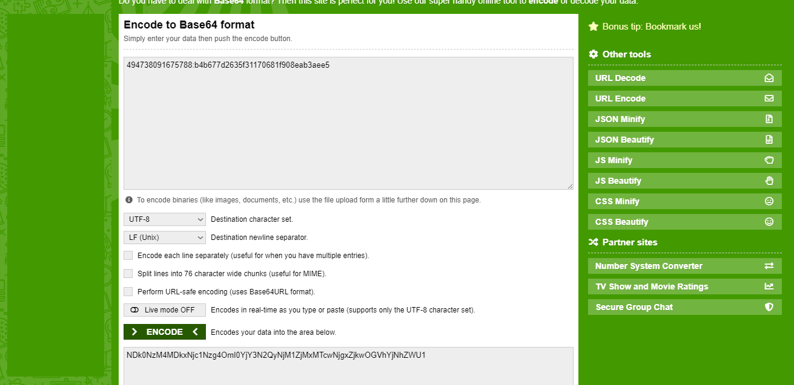

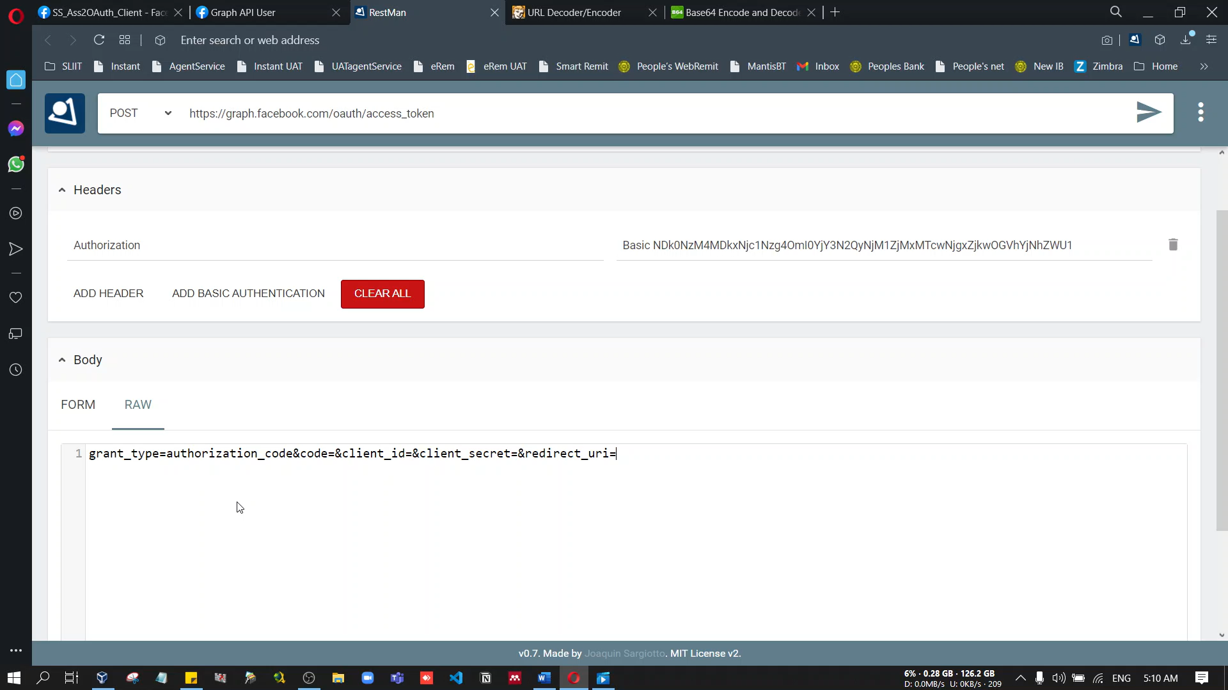

When sending the request, use a HTTP Client browser plugin like RESTMan.

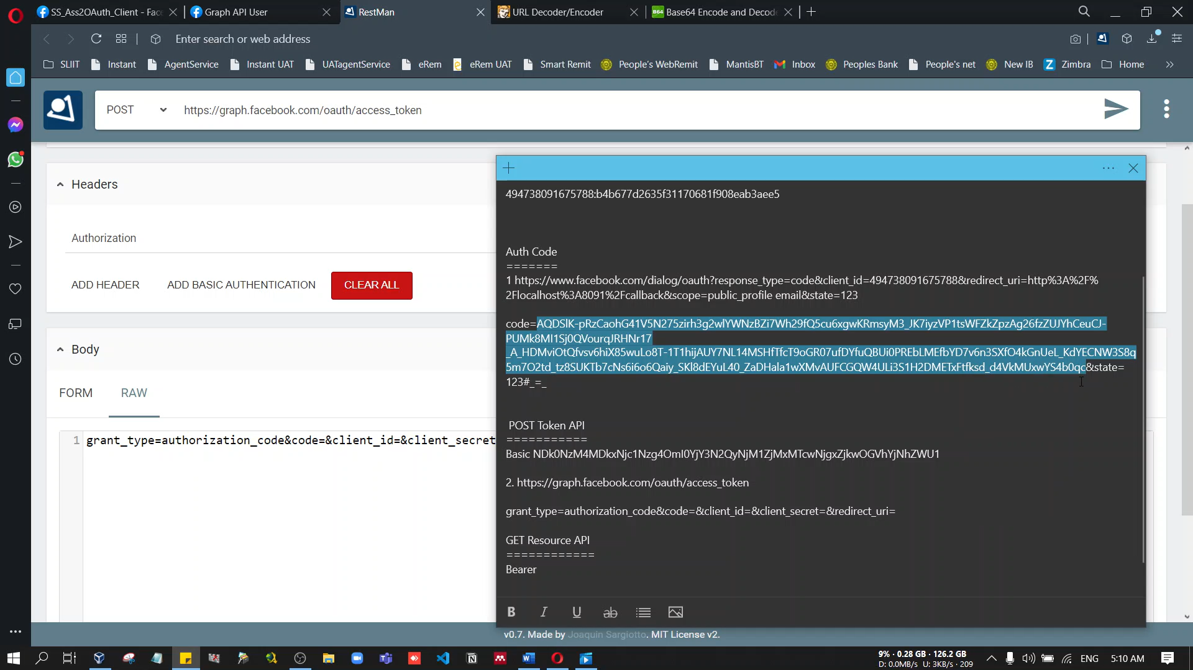

grant_type=authorization_code&code=AQC_VsiUpf3QIXVAFNFFUKJifsGfXw3ZHLr5kjMT7dDnmTKKP6FPud6P569oaOA6Ly6XVr8DTQDC3-tW4xpETFW47AlcdiJRPiFhliiSMfxuSCO3H9mIrdQF9F2NLEu4NHMH_2N7qNzXi65m2hu8qOiMb-13oxVtoIHrpD1HfaRmCNb5ACvz0iUEEflNdHiTenXnNJtRl_kIPK-cD_aC5waUxCE11pGYyzeHfhYuCGN1AgCPfyNdoFmGfdt32tItNykaBB-dMppbkk3DYrQA0-JFoz4BPvszAj8NkTdb1eAjSVVMiJ9jXZCe9mmtjLT0UvQ&client_id=494738091675788&client_secret=b4b677d2635f31170681f908eab3aee5&redirect_uri=http%3A%2F%2Flocalhost%3A8091%2Fcallback

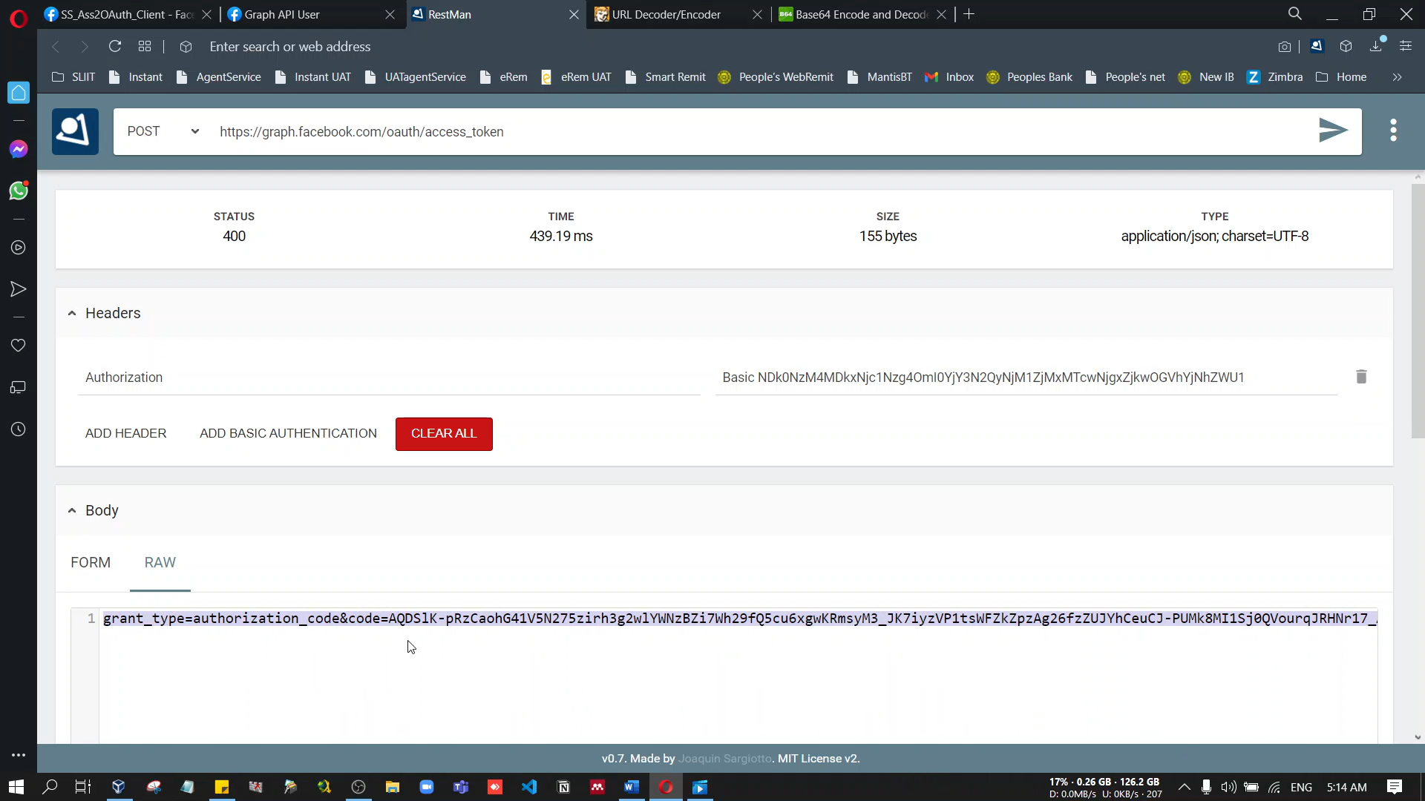

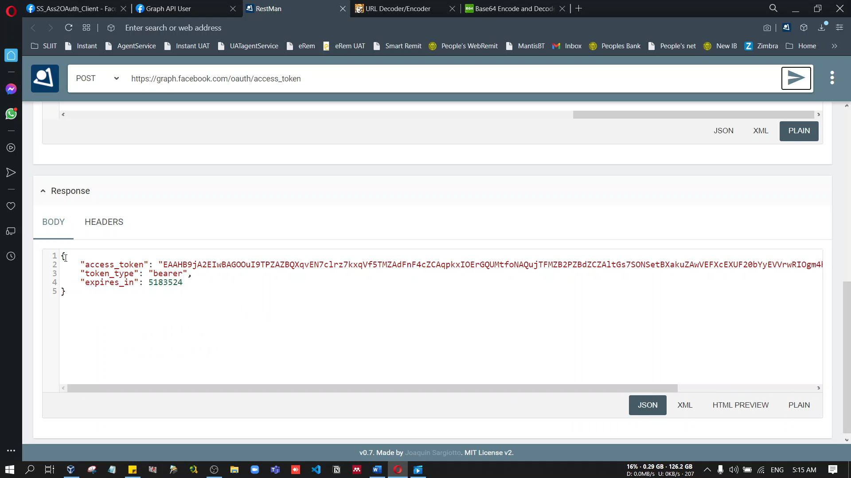

{

"access_token": "EAAHB9jA2EIwBAGOOuI9TPZAZBQXqvEN7clrz7kxqVf5TMZAdFnF4cZCAqpkxIOErGQUMtfoNAQujTFMZB2PZBdZCZAltGs7SONSetBXakuZAwVEFXcEXUF20bYyEVVrwRIOgm4hg4qyVPlwy6SlOIvO4pXnsdOA7ZAWcEZD",

"token_type": "bearer",

"expires_in": 5183524

}

**Step 4 - Retrieving User Resources from Facebook, providing the Access Token**

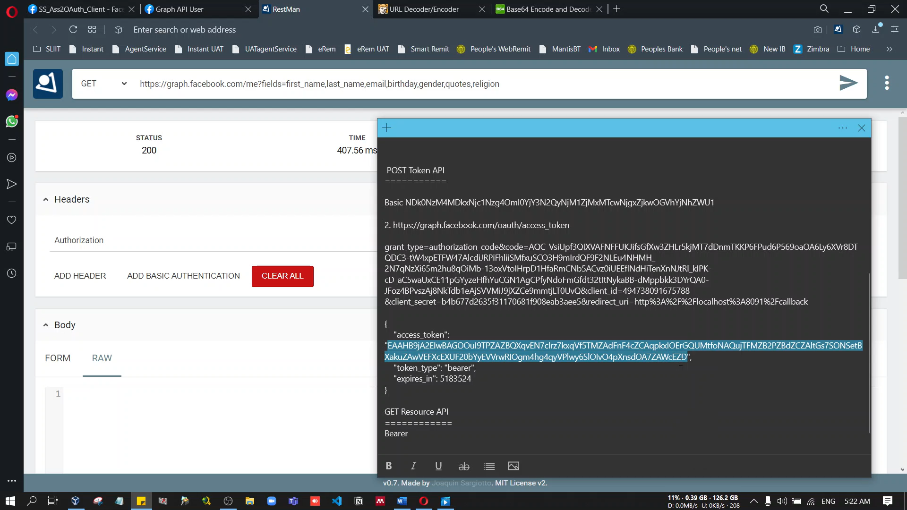

Send a HTTP GET request to https://graph.facebook.com/me?fields and in response, will get the user’s First Name, Last Name Email and ID by a JSON response.

